National Care Company Manufacturing Facilities & Locations
1. National Care Company (NCC)
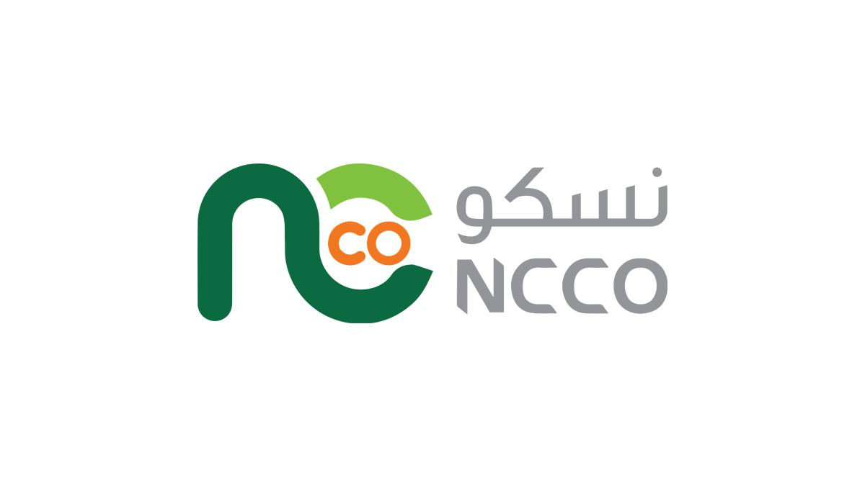
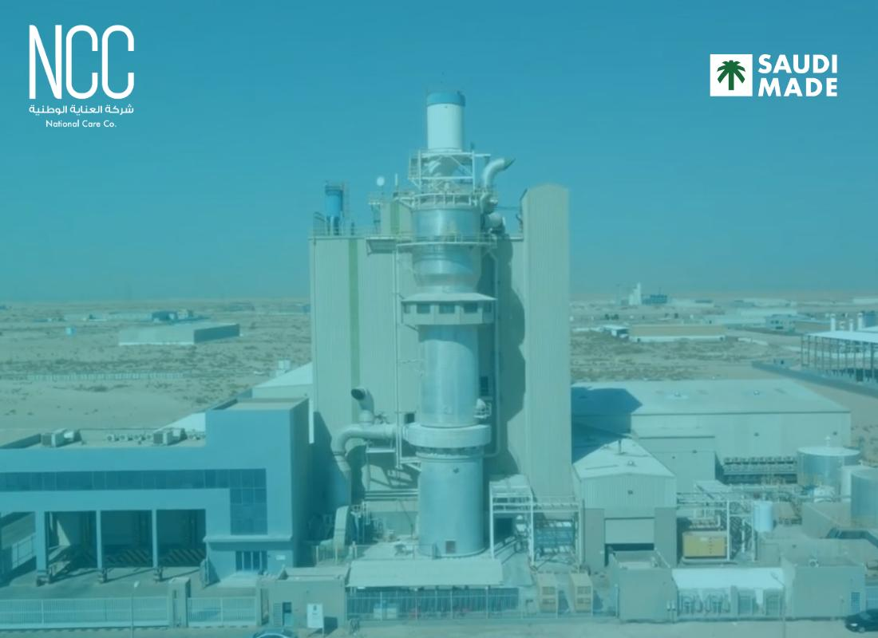
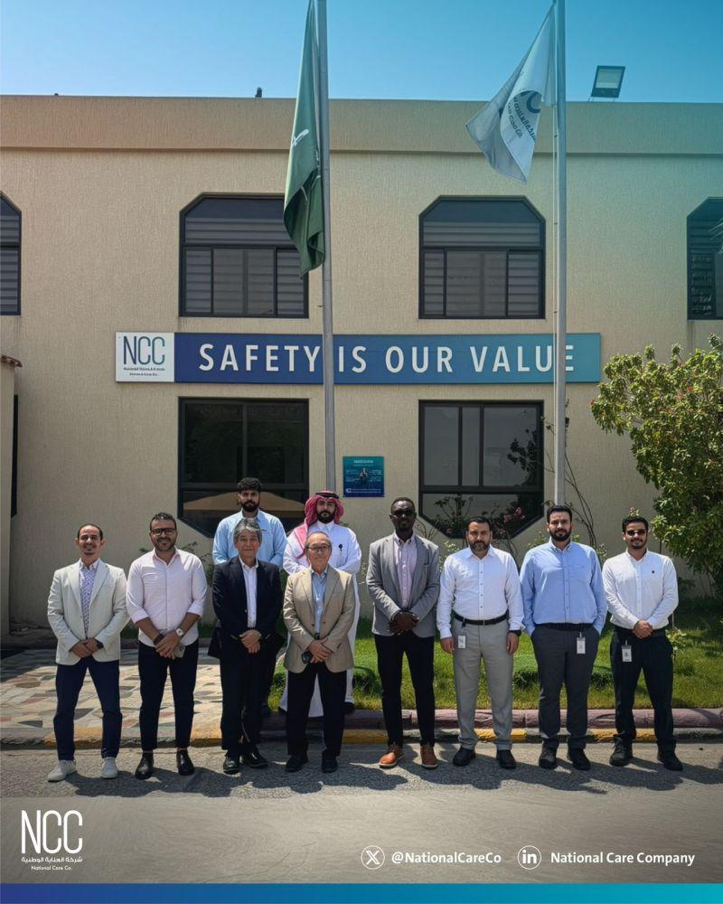
6
Main Website:
National Care Company Official Website
Head Office / Main Manufacturing Location:
Second Industrial City, Dammam, Saudi Arabia
Google Maps:
NCC Dammam Location
https://maps.app.goo.gl/NcMcB9VGkJXdf5qL6
<iframe src="https://www.google.com/maps/embed?pb=!1m14!1m8!1m3!1d14312.929884587378!2d49.9869251!3d26.2541175!3m2!1i1024!2i768!4f13.1!3m3!1m2!1s0x3e361e5d18539481%3A0x375a3cfda81265a9!2s27%20St%2C%20Dammam%20Saudi%20Arabia!5e0!3m2!1sen!2seg!4v1779282041429!5m2!1sen!2seg" width="600" height="450" style="border:0;" allowfullscreen="" loading="lazy" referrerpolicy="no-referrer-when-downgrade"></iframe>
2. Saudi Detergent Powder Factory | SDPF
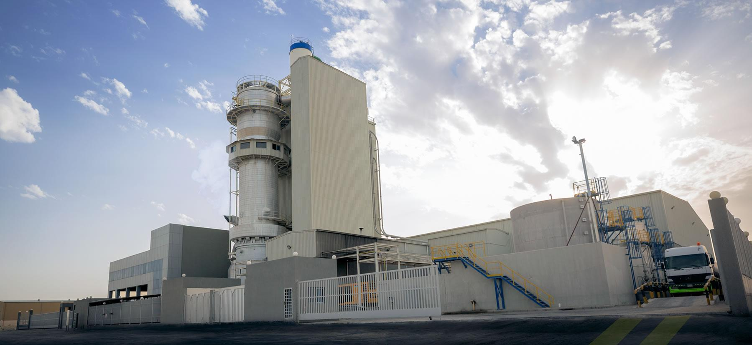
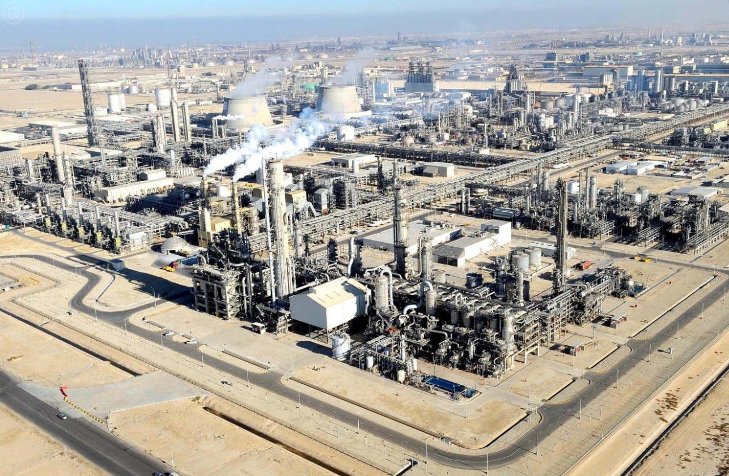
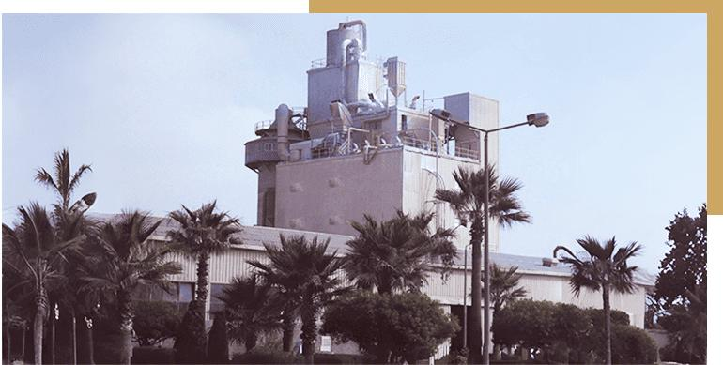
5
Factory Information:
Referenced as a detergent powder manufacturing facility under NCC/SIDCO group.
Location:
Third Industrial City – Dammam, Saudi Arabia
Google Maps:
SDPF - Third Industrial City Dammam

https://maps.app.goo.gl/qig5zP5ehPy5PkEDA
<iframe src="https://www.google.com/maps/embed?pb=!1m18!1m12!1m3!1d3578.1007832330806!2d49.99227037541719!3d26.25839227704327!2m3!1f0!2f0!3f0!3m2!1i1024!2i768!4f13.1!3m3!1m2!1s0x3e361e41a6939195%3A0xbd41864dc59b9e97!2s3%20St%2C%20Dammam%20Saudi%20Arabia!5e0!3m2!1sen!2seg!4v1779282087612!5m2!1sen!2seg" width="600" height="450" style="border:0;" allowfullscreen="" loading="lazy" referrerpolicy="no-referrer-when-downgrade"></iframe>

3. Saudi Aerosol Factory | SAF
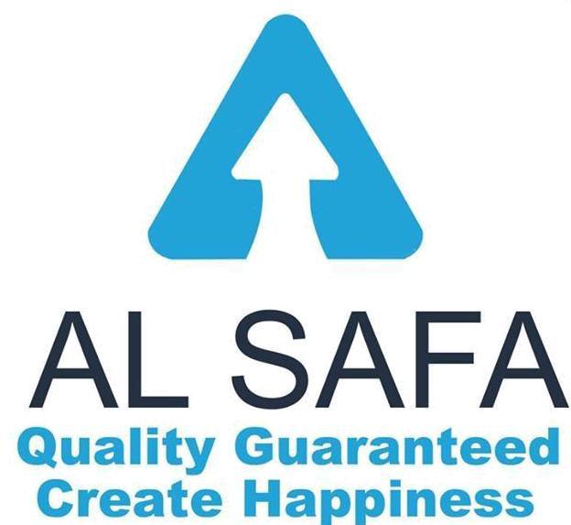

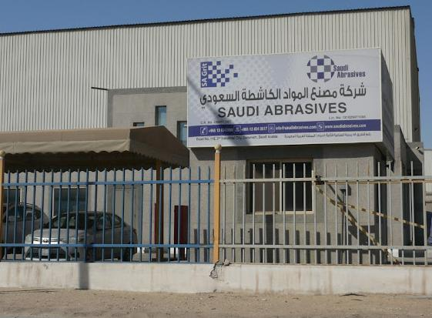
5
Factory Locations Mentioned:
Dammam Industrial City & Jeddah Industrial City
Dammam Location
Second Industrial City – Dammam
Google Maps:
SAF Dammam Location
https://maps.app.goo.gl/UBEhKEcNHpSeTC319

<iframe src="https://www.google.com/maps/embed?pb=!1m18!1m12!1m3!1d57251.450030842236!2d49.93058171234783!3d26.254664323384834!2m3!1f0!2f0!3f0!3m2!1i1024!2i768!4f13.1!3m3!1m2!1s0x3e361e91873d79b9%3A0xab3c27390473718c!2sDammam%202nd%20Industrial%20City%2C%20Dammam%20Saudi%20Arabia!5e0!3m2!1sen!2seg!4v1779282167075!5m2!1sen!2seg" width="600" height="450" style="border:0;" allowfullscreen="" loading="lazy" referrerpolicy="no-referrer-when-downgrade"></iframe>
Jeddah Location
First Industrial City – Jeddah
Google Maps:
SAF Jeddah Location
https://maps.app.goo.gl/8e5ZvDpdXFwsx2Bo9

<iframe src="https://www.google.com/maps/embed?pb=!1m18!1m12!1m3!1d3713.951931828226!2d39.203761075267735!3d21.43113428032079!2m3!1f0!2f0!3f0!3m2!1i1024!2i768!4f13.1!3m3!1m2!1s0x15c3c9182845e485%3A0x1a8489567838ca5b!2sIndustrial%20City%20Modon%201%20Phase1!5e0!3m2!1sen!2seg!4v1779282134474!5m2!1sen!2seg" width="600" height="450" style="border:0;" allowfullscreen="" loading="lazy" referrerpolicy="no-referrer-when-downgrade"></iframe>

4. National Detergent Powder Factory | NDPF
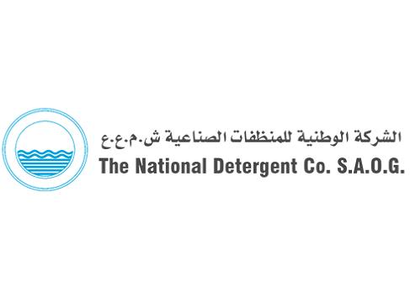


5
Likely Manufacturing Zone:
Second Industrial City – Dammam
Google Maps:
NDPF Dammam Location

https://maps.app.goo.gl/8e5ZvDpdXFwsx2Bo9

<iframe src="https://www.google.com/maps/embed?pb=!1m18!1m12!1m3!1d3713.951931828226!2d39.203761075267735!3d21.43113428032079!2m3!1f0!2f0!3f0!3m2!1i1024!2i768!4f13.1!3m3!1m2!1s0x15c3c9182845e485%3A0x1a8489567838ca5b!2sIndustrial%20City%20Modon%201%20Phase1!5e0!3m2!1sen!2seg!4v1779282134474!5m2!1sen!2seg" width="600" height="450" style="border:0;" allowfullscreen="" loading="lazy" referrerpolicy="no-referrer-when-downgrade"></iframe>

5. Saudi Industrial Detergent Company | SIDCO
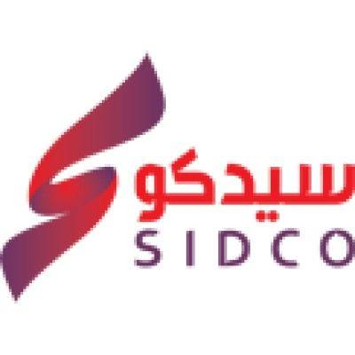


6
Official Website:
SIDCO Official Website
Exact Address:
SIDCO Building, 27th Street, Second Industrial City, Dammam 31461, Saudi Arabia
Google Maps:
SIDCO Exact Location on Google Maps
https://maps.app.goo.gl/XuxiD8PUWKFQ557CA
<iframe src="https://www.google.com/maps/embed?pb=!1m18!1m12!1m3!1d28621.62257787303!2d49.96291053319555!3d26.271306730227927!2m3!1f0!2f0!3f0!3m2!1i1024!2i768!4f13.1!3m3!1m2!1s0x3e361e435356ca7f%3A0xcfd0ca4af8048e93!2sSaudi%20Industrial%20Detergents%20Company.34326!5e0!3m2!1sen!2seg!4v1779282276066!5m2!1sen!2seg" width="600" height="450" style="border:0;" allowfullscreen="" loading="lazy" referrerpolicy="no-referrer-when-downgrade"></iframe>

6. Plastic Blow Molding Manufacturing | RNTIC
لم أجد موقع رسمي أو بيانات عامة دقيقة خاصة بـ RNTIC، لكن غالبًا المصنع ضمن منظومة مصانع NCC في المنطقة الصناعية بالدمام.
Google Maps (Industrial Area Reference):
RNTIC Industrial Area Reference
https://maps.app.goo.gl/UBEhKEcNHpSeTC319

<iframe src="https://www.google.com/maps/embed?pb=!1m18!1m12!1m3!1d57251.450030842236!2d49.93058171234783!3d26.254664323384834!2m3!1f0!2f0!3f0!3m2!1i1024!2i768!4f13.1!3m3!1m2!1s0x3e361e91873d79b9%3A0xab3c27390473718c!2sDammam%202nd%20Industrial%20City%2C%20Dammam%20Saudi%20Arabia!5e0!3m2!1sen!2seg!4v1779282167075!5m2!1sen!2seg" width="600" height="450" style="border:0;" allowfullscreen="" loading="lazy" referrerpolicy="no-referrer-when-downgrade"></iframe>

Geographical Distribution Summary
Facility | City | Industrial Area
SDPF | Dammam | Third Industrial City
SAF | Dammam / Jeddah | Second Industrial City / First Industrial City
NDPF | Dammam | Second Industrial City
SIDCO | Dammam | Second Industrial City
RNTIC | Dammam | Likely Second Industrial City

Official Group References
- National Care Company (NCC)
- SIDCO

